|  |  |  |  |
| --- | --- | --- | --- |
| State of Florida  pscSEAL | | Public Service Commission  Capital Circle Office Center ● 2540 Shumard Oak Boulevard Tallahassee, Florida 32399-0850  -M-E-M-O-R-A-N-D-U-M- | |
| DATE: | November 21, 2024 | | |
| TO: | Office of Commission Clerk (Teitzman) | | |
| FROM: | Division of Engineering (Thompson, Davis, Ellis, King, Sanchez, Wooten) TB  Office of the General Counsel (Imig, Harper, Rubottom) AEH  Division of Accounting & Finance (Cicchetti) ALM | | |
| RE: | Docket No. 20240012-EG – Commission review of numeric conservation goals (Florida Power & Light Company). | | |
| AGENDA: | 12/03/24 – Regular Agenda – Post-Hearing Decision – Participation is Limited to Commissioners and Staff | | |
| COMMISSIONERS ASSIGNED: | | | All Commissioners |
| PREHEARING OFFICER: | | | Graham |
| CRITICAL DATES: | | | 01/01/25 – Pursuant to section 366.82(6), F.S., the Commission must review conservation goals at least every five years. New conservation goals must be set by January 1, 2025. |
| SPECIAL INSTRUCTIONS: | | | None |

Background

Pursuant to the Florida Energy Efficiency and Conservation Act (FEECA),[1] the Commission must adopt appropriate goals to increase the efficiency of energy consumption, reduce and control the growth rates of electric consumption and weather-sensitive peak demand, increase the conservation of expensive resources, and encourage development of demand-side renewable energy resources.

The Commission implements FEECA for electric utilities through Rule 25-17.0021, Florida Administrative Code (F.A.C.) Pursuant to that rule, the Commission establishes annual kilowatt (KW) and kilowatt-hour (KWh) goals for Residential and Commercial/Industrial customer classes.[2] The goals are based on (1) an assessment of the technical potential of available conservation and efficiency measures, and (2) an estimate of the total cost-effective KW and KWh savings reasonably achievable through demand-side management (DSM) programs in each utility’s service area over a ten-year period.[3] The goals are annual targets for conservation, with KW goals relating to seasonal—summer and winter—demand savings, and annual KWh goals relating to annual energy savings. Pursuant to section 366.82(6), F.S., the Commission must review the goals of each utility subject to FEECA at least every five years. Goals were last established for Florida Power & Light Company (FPL) in 2019 by Order No. PSC-2019-0509-FOF-EG.[4] Therefore, new goals must be established for FPL by January 1, 2025.

On January 5, 2024, this docket was established to review and adopt conservation goals for FPL. By the Order Consolidating Dockets and Establishing Procedure, Order No. PSC-2024-0022-PCO-EG, issued January 23, 2024, the dockets were consolidated for purposes of hearing, a tentative list of issues was set forth, and controlling dates were established. On April 2, 2024, FPL filed its petition for approval of numeric conservation goals, along with supporting testimony and exhibits.[5] At an informal meeting between parties and Commission staff on June 27, 2024, additional issues were identified, and the final issue list was set for hearing by the Prehearing Order, Order No. PSC-2024-0293-PHO-EG, issued August 2, 2024. On August 5, 2024, joint stipulations were filed that fully resolved all disputed issues, as set forth on pages 3-4 of Attachment A.[6]

Pursuant to Notice, and in accordance with Rule 28-106.209, F.A.C., the Commission held an evidentiary hearing on August 8, 2024, at which it considered whether to accept the stipulations. By a bench vote, the Commission approved stipulations on Issues 1-9 and 11-14 and, with respect to Issue 10, allowed FPL to file a post-hearing brief.

This recommendation addresses the remaining Issue 10, which deals with FPL’s proposed heating, ventilation, and air conditioning (HVAC) on-bill tariff option (“HVAC On-Bill”), an expansion to the company’s existing On Call® DSM program (“On Call®”). Specifically, Issue 10 states:

Is FPL’s proposed HVAC On-Bill option for its existing Residential On-Call program with its associated HVAC Services Agreement (proposed Tariff sheets 9.858 through 9.866) a regulated activity within the jurisdiction of the Commission? If not, should the savings associated with FPL’s HVAC On-Bill option and HVAC Services Agreement be removed from its conservation goals?

The ultimate issue to be determined is whether the estimated savings associated with FPL’s proposed HVAC On-Bill option should be counted toward establishing FPL’s conservation goals. If the HVAC On-Bill option is not within the Commission’s jurisdiction, the associated savings should be removed from FPL’s proposed goals.

As a fallout to the Commission’s decision on Issue 10, Issue 12, which deals with what goals should be established for FPL, must be revisited. The Commission has jurisdiction over this matter pursuant to sections 366.80 through 366.82, F.S.

Undisputed Facts in the Record

Existing HVAC Programs for FPL Customers

FPL currently offers several DSM programs for residential customers as part of its FEECA plan. For example, FPL offers a “Residential HVAC Program” that provides customers a rebate for installing a high-efficiency HVAC system. (EXH 152)[7] FPL customers can also participate in the “Residential Load Management (On Call®)” program (“On Call®”), a demand response program that provides participating customers with bill credits in exchange for granting FPL the right to periodically control customer-owned HVAC, water heating, and pool pump appliances. (TR 120-21; EXH 152[8]) Additionally, FPL’s unregulated affiliate company, FPL Energy Services (“FPLES”), offers HVAC financing options to customers inside and outside FPL’s service territory. For example, FPLES offers a traditional HVAC financing arrangement under which ownership would transfer to the customer upon installation of the HVAC unit. (EXH 154, MPN E289) FPLES also offers a “Stress Free AC” program, an HVAC leasing option under which FPLES retains ownership of the HVAC unit and provides ongoing maintenance services for the unit. (EXH 154, MPN E289; EXH 228, MPN E4149-51)

FPL’s Proposed HVAC On-Bill Option

In Issue 10, FPL is requesting the Commission include in its conservation goals the estimated savings associated with the HVAC On-Bill option, a new DSM measure proposed by FPL as an expansion of its existing On Call® program. The proposed HVAC On-Bill option[9] would allow customers to acquire a new HVAC unit through a separate tariff agreement and, after making all payments required by the agreement, to take ownership of the unit. (TR 121) FPL would offer participating customers the option of a 10-, 12-, or 15-year term, dependent on the life of the particular HVAC’s warranty. (EXH 151, MPN E149) Under the HVAC On-Bill option, FPL would own and maintain the HVAC unit for the duration of the term, and the monthly charge would cover the capital cost of the HVAC equipment plus all maintenance and repairs of the unit for the duration of the agreement. Additionally, participating customers would be required to remain subject to FPL’s On Call® load management program for the duration of the HVAC On-Bill term—a minimum of 10 years. (EXH 156[10])

What is unique about FPL’s proposed HVAC On-Bill option compared to its other HVAC financing and service offerings discussed above is that the On-Bill option would combine into a single DSM measure two distinct activities: (1) the provision of a new HVAC unit (installation, maintenance, title transfer, etc.); and (2) the provision of load management services (HVAC load control device, management, and load control credits). (FPL BR 11) Participating customers would receive a new HVAC unit as well as the load management equipment. Also unlike FPL’s other DSM programs, HVAC On-Bill option does not require that the new HVAC unit replace an older, less efficient unit, nor does it require that the new unit exceed minimum appliance efficiency standards. (EXH 154, MPN E238[11])

As proposed, the HVAC On-Bill option would require a participating customer to make levelized, monthly payments over the term of the 10-15 year agreement that cover three main categories of projected program costs:

1. Capital Cost: HVAC and load control equipment and installation, information technology and billing system architecture;
2. Operations and Maintenance Expense: ongoing maintenance and labor, information technology support, customer service and billing support; and
3. Load Management Credit: reduction in the total cost to be collected in exchange for the right to control the HVAC units during peak periods.

(FPL BR 14)

The capital costs would include a return on FPL’s investment through a return on unrecovered investment using the Commission-approved weighted average cost of capital and a return of capital through depreciation expense. (EXH 151, MPN E151) FPL estimates that for a minimum efficiency HVAC unit costing FPL $8,000, a participant would pay a total of approximately $19,400, or 240% of the unit’s original cost, over the term of their HVAC On-Bill agreement. (EXH 154, MPN E290)

All costs associated with the HVAC On-Bill option, including those identified above, would initially be recovered from the general body of ratepayers through the Energy Conservation Cost Recovery (“ECCR”) clause. (FPL BR 14; TR 122)The program revenues received from participating customers would also flow through the ECCR clause in order to offset the program expense. (EXH 151, MPN E151) The HVAC On-Bill option is designed so that the monthly payments received from a participant would eventually cover all costs of that agreement and fully reimburse the general body of ratepayers. Even if the agreement is terminated early, the participant would be required to pay a “Termination Fee” that includes the unrecovered capital costs and any advance payment of monthly load management credits. (EXH 156[12]; EXH 151, MPN E154) However, FPL clarified that in the event of any under- or over-recovery of program expenses associated with a single participant’s agreement, “FPL will adjust pricing for new program participants” to help ensure that under-recovered costs are recovered from program participants and not from the general body of ratepayers.” (EXH 154, MPN E237-38)

The HVAC On-Bill agreement provides that FPL would retain title and ownership of the HVAC unit during the term of the agreement until a participant elects to take title to the HVAC unit from FPL after making all the payments required by the agreement. (EXH 156[13]; EXH 151, MPN E154) The participant could also pursue a “Customer Purchase Option” in the case of early termination, under which they would take title from FPL upon payment of the Termination Fee. (EXH 156[14]) FPL expects that the majority of HVAC On-Bill agreements would result in transfer of title and ownership to the HVAC unit from FPL to the customer once the service agreement terms are completed. (EXH 228, MPN E4218)

Discussion of Issues

Issue 10:

 Is FPL’s proposed HVAC On-Bill option for its existing Residential On-Call program with its associated HVAC Services Agreement (proposed Tariff sheets 9.858 through 9.866) a regulated activity within the jurisdiction of the Commission? If not, should the savings associated with FPL’s HVAC On-Bill option and HVAC Services Agreement be removed from its conservation goals?

Recommendation:

 No, FPL’s proposed HVAC On-Bill option is not within the jurisdiction of the Commission because it appears to include the sale of HVAC units as defined by Florida law. Additionally, the program would consider profit and loss from such sales in rates charged to customers, and appears to mix non-jurisdictional appliance sales with jurisdictional FEECA investments for ratemaking purposes, which Chapter 366, F.S., appears not to allow. Further, staff recommends that the proposed stipulation offered by FPL does not answer the question at issue. As such, staff recommends that the Commission not approve the proposed stipulation language, and recommends that the savings associated with the HVAC On-Bill option and HVAC Services Agreement be removed from FPL’s conservation goals. (Rubottom, Thompson)

Staff Analysis:

Summary of Staff’s Analysis

While staff agrees with the parties to the extent that FPL’s proposed HVAC On-Bill option would allow customers to access new HVAC equipment in a way that passes the Commission’s cost-effectiveness tests, staff disagrees that the measure should be included in FPL’s proposed DSM goals for the following reasons, which are discussed more fully below:

* Section 672.106(1), F.S., defines a “sale” as “the passing of title from the seller to the buyer for a price.” FPL’s provision of a new HVAC unit under the HVAC On-Bill option appears to meet that definition because FPL would transfer title to the HVAC unit from FPL to the participating customer in exchange for fulfillment of all payment obligations.
* Section 366.05(2), F.S., provides that “[n]o profit or loss shall be taken into consideration by the commission from the sale of [appliances] in arriving at any rate to be charged for service by any public utility.” The HVAC On-Bill option appears to consider profit or loss from the sale of HVAC units in rates charged for service, because both the participants and the general body of ratepayers would pay (1) a return on equity on the capital cost of the HVAC units; and (2) any potential under- or over-recovery of the original cost of units from prior agreements.
* Florida law requires the Commission to ensure that a utility’s ratepayers do not subsidize non-jurisdictional activity. *See* Sections 366.04(1), 366.05(9), 366.093(1), F.S. The Commission has long considered the sale of appliances to be a non-utility activity, describing it as “non-jurisdictional” or “non-utility investment.” Thus, the HVAC On-Bill’s mixing of non-jurisdictional HVAC sales with jurisdictional FEECA load control investments appears to be contrary to Florida law and Commission practice.

For these reasons, as discussed in more detail below, staff recommends the Commission find that the HVAC On-Bill option is not within the jurisdiction of the Commission and remove the savings associated with the HVAC On-Bill option from FPL’s conservation goals.

Preliminary Matters

Prior to addressing the substance of the HVAC On-Bill option and the merits of FPL’s argument, there are several preliminary matters raised by FPL that relate to the procedural posture of the case.

Due Process

FPL suggests in its post-hearing brief, although it did not do so at the hearing, that due process concerns are raised by the fact that the Commission asked it to file a post-hearing brief to support its position on Issue 10 when all other parties have stipulated the issue. FPL states that staff did not file testimony or take a position on the issue, and that FPL “must try to anticipate and preemptively address a staff recommendation . . . that will be issued after FPL files its post-hearing brief.” (FPL BR 8) (emphasis in original)

Staff submits that the Commission’s action did not raise any due process concerns for the following reasons:

* The circumstances of this case are no different from any other case before the Commission. Because the utility bears the burden of proof, the substance of staff’s recommendation depends upon the evidence and arguments the utility presents to the Commission. Staff is not required to take a position on the issues in order to make a recommendation to the Commission once all evidence has been collected and reviewed.
* As the Florida Supreme Court has stated, “[t]he fundamental requirements of due process are satisfied by reasonable notice and a reasonable opportunity to be heard.” *Citizens v. Fla. Pub. Serv. Comm’n*,146 So. 3d 1143, 1154 (Fla. 2014) (quoting *Fla. Pub. Serv. Comm'n v. Triple “A” Enters., Inc.*, 387 So. 2d 940, 943 (Fla. 1980)). Far from being denied due process, the Commission afforded FPL an additional opportunity to be heard and meet its burden of proof by filing a post-hearing brief in support of its position.
* Issue 10 was identified and added to the preliminary issue list on June 27, 2024, at the informal meeting between FPL, Commission staff, and other parties, and staff conducted extensive discovery on the issue. Moreover, at the hearing, the Commission extracted Issue 10 from the other, stipulated issues so FPL could have an additional opportunity to address those concerns.

Because FPL was given reasonable notice and an opportunity to be heard, and has not been prejudiced in any way, the Commission did not err when it asked FPL to file a brief on Issue 10 before it received staff’s recommendation. As such, there is no due process concern with how the Commission chose to address Issue 10.

Appropriate Standard of Review

FPL also asks the Commission to consider its position on Issue 10 as part of a comprehensive “settlement” of its goalsetting case, in light of the fact that it reached stipulations on all issues with the intervening parties. (FPL BR 4) FPL requests the Commission to apply the standard of review applicable to rate case settlements and consider whether the agreement, taken as a whole, is in the “public interest.” *Id.* (citing *Floridians Against Increased Rates v. Clark*, 371 So. 3d 905, 910 (Fla. 2023)).

Staff disagrees with FPL’s conclusion that the Commission is precluded from considering and deciding Issue 10 separately and distinctly from other stipulated issues already approved by the Commission. The Commission’s practice is to treat a stipulation as a proposed resolution of a distinct issue in a case, and a proposed settlement agreement as resolving the case as a whole.

Additionally, at the hearing, rather than taking one vote to approve the parties’ agreement as a whole, as it would have done with a settlement agreement, the Commission voted to resolve distinct issues, approving the stipulated positions on Issues 1-9 and 11-14 but not Issue 10. (TR 20) At that time, FPL did not refer to the stipulations as a “settlement,”[15] and it did not oppose staff’s recommendation to allow parties to file post-hearing briefs on Issue 10.[16]

Because the parties filed stipulations rather than a settlement agreement, and because the Commission explicitly treated Issue 10 as separate and distinct from the other stipulated issues, staff recommends that the Commission make factual and legal findings as necessary to resolve Issue 10.

The Proposed Stipulation on Issue 10 Does Not Answer the Question at Issue

Because the question of whether FPL’s proposed conservation goals are appropriate depends in part on whether FPL’s potential programs are within the Commission’s jurisdiction, Issue 10 asks whether FPL’s HVAC On-Bill option is an activity within the jurisdiction of the Commission. However, the proposed stipulation on Issue 10 does not answer that question. The parties’ stipulation on Issue 10 states:

The Parties stipulate and agree that the record supports a Commission finding that FPL’s proposed HVAC On-Bill option expands the existing On Call® load-management program to allow greater customer access to new energy-saving HVAC equipment in a way that also passes the RIM cost effectiveness test, and should be included in FPL’s proposed DSM Goals.

While this language includes proposed findings of fact relevant to determining whether the HVAC On-Bill option would be effective in furthering the objectives of FEECA, it does not address whether the DSM measure is within the jurisdiction of the Commission.[17] Therefore, because the stipulation does not answer the question at issue, staff recommends that the Commission not approve the proposed stipulation language.

Nevertheless, FPL presented arguments in its post-hearing brief that addressed Issue 10. Therefore, this recommendation will provide staff’s analysis and recommendation on the merits of Issue 10, addressing as necessary the evidence and arguments presented by FPL.

Staff’s Analysis

Pursuant to section 366.82(2), F.S., the Commission must evaluate whether the goals requested by FPL are appropriate. Issue 10 addresses whether the HVAC On-Bill option is within the jurisdiction of the Commission as required by FEECA, and, as a fall out question, whether the estimated savings associated with the program are appropriate to include in FPL’s conservation goals.

1. Defining the Proposed Activity: The HVAC On-Bill Option Includes the Sale of HVAC Units.

In order to determine whether the HVAC On-Bill option is within the Commission’s jurisdiction, the Commission must examine the nature of the activity involved in the measure, not merely FPL’s characterization of the activity. *See, e.g.*, *Florida Power & Light Co. v. Albert Litter Studios, Inc.*, 896 So. 2d 891, 893 (Fla. 1st DCA 2005) (stating that “it is the nature of the relief sought, not the language of the complaint, that ultimately determines which tribunal has jurisdiction over the claim”).

FPL’s proposed HVAC On-Bill option would combine into a single DSM measure two distinct categories of activity: (1) the provision of a new HVAC unit (installation, maintenance, title transfer, etc.); and (2) load management services (HVAC load control device, management, and load control credits).[18] (FPL BR at 11) There is no question that the load control aspect of HVAC On-Bill is within the Commission’s jurisdiction, as it is explicitly authorized under FEECA and is in fact already available to customers through FPL’s existing On Call® program. *See* Section 366.82(7), F.S.; (EXH 228, MPN E4133) However, the HVAC-related aspect of the measure is, as characterized by FPL, “innovative” for a utility conservation plan under FEECA. (TR 121; EXH 228, MPN E4134[19])

Staff’s understanding of the legal nature of the HVAC services offered under the HVAC On-Bill option differs from that of FPL, leading to opposite conclusions on the question of whether the program is within the Commission’s jurisdiction.

Section 672.106(1), F.S., defines the term “sale” as “the passing of title from the seller to the buyer for a price.”[20] The HVAC On-Bill option agreement provides that:

* The participating customer would pay FPL an agreed-upon monthly price for the term of the agreement. (TR 121; EXH 156[21])
* Upon payment of all obligations required by the agreement, a participant would have the right to take title to the HVAC unit from FPL. (EXH 151, MPN E154; EXH 156[22])

Put simply, the HVAC On-Bill tariff allows the participant to take title to the HVAC unit upon making all required payments. Therefore, because the transaction includes FPL passing the HVAC unit title to customers in exchange for a price, the transaction appears to meet the definition of a “sale” under section 672.106(1), F.S.

In discovery, FPL agreed that if a participant exercises the “Customer Purchase Option” under the HVAC Services Agreement, “title to the HVAC unit passes from FPL to the participant in exchange for . . . the ‘purchase option price.’” (EXH 154, MPN E284[23]) Thus, FPL seemingly agreed with staff that under certain scenarios, its conduct pursuant to the HVAC Services Agreement meets the definition of a “sale” as defined by section 366.05(2), F.S.

However, FPL suggests in its post-hearing brief that its provision of HVAC units is not a sale because title to the HVAC unit would not pass to the participant at the time the HVAC unit is delivered. (FPL BR 18) FPL relies upon section 672.401(2), F.S., which provides that “[u]nless otherwise explicitly agreed title passes to the buyer at the time and place at which the seller completes her or his performance with reference to the physical delivery of the goods.” Staff disagrees that the mere separation in time of the distinct acts of HVAC installation and title transfer render the transaction not a sale. Section 672.401(1), F.S., specifies that “*under a contract for sale*, . . . title to goods passes from the seller to the buyer in any manner and on any conditions explicitly agreed on by the parties.” (emphasis added) Thus, the timing of title transfer within a contract does not appear to have any bearing on the existence or validity of a contract for sale. In other words, a transaction is *still a sale* when the contract provides that seller reserves title to the goods until certain conditions are met by the buyer. *See, e.g.*, *Suburbia Fed. Sav. and Loan Ass’n v. Bel-Air Conditioning Co.*, 385 So. 2d 1151, 1152-53 (Fla. 4th DCA 1980) (construing a “contract for the sale of air conditioning equipment” and holding that a provision conditioning title transfer upon seller’s “payment of the entire purchase price” created a “security interest” under Florida law). The inclusion of contract provisions requiring that customer payments must occur prior to FPL passing the HVAC title to the customer appear to be nothing more than a condition precedent within the underlying contract for sale under Florida law.

FPL also offers a variation on the above argument, suggesting that there is no sale under the HVAC On-Bill option because title to the HVAC unit would not transfer until “the end of the contract term,” after the participant had fulfilled all obligations under the agreement. (FPL BR 19) FPL states that the participant’s option to take title to the HVAC “is a future option” that is “not operative until the expiration, assignment, or early termination of the agreement.” (FPL BR 20) However, the provisions in the HVAC On-Bill agreement itself would obligate FPL to transfer the title upon certain conditions. Thus, the agreement between FPL and the participant remains intact from start to finish, and does not “expire” until after FPL discharges its duties thereunder by transferring the HVAC title to the participant.

Finally, FPL argues that under Generally Accepted Accounting Principles (“GAAP”), the HVAC On-Bill option is a “service contract,” rather than a sale or a lease, because FPL would “use and maintain the asset to deliver service to the customer while retaining control of that asset.” (FPL BR 20) However, FPL’s argument does not refute the fact that under the HVAC On-Bill option’s “Optional HVAC Services Agreement” tariff, title to the HVAC unit would eventually pass to the participating customer in exchange for a price. *See* (EXH 156)[24] Therefore, even if the agreement is considered a service contract under GAAP, the transaction still appears to include the sale of HVAC units under Florida law.

1. Section 366.05(2), F.S., and the HVAC On-Bill Option

Florida law requires that if a public utility engaged in providing ordinary public utility services also engages in the sale of appliances or other merchandise, certain restrictions apply. Section 366.05(2), F.S., provides:

Every public utility, as defined in s. 366.02, which in addition to the production, transmission, delivery or furnishing of heat, light, or power also sells appliances or other merchandise shall keep separate and individual accounts for the sale and profit deriving from such sales. *No profit or loss shall be taken into consideration* by the commission from the sale of such items *in arriving at any rate to be charged for service* by any public utility. (emphasis added)

As the Commission has previously stated, section 366.05(2), F.S., does not ban the sale of appliances by public utilities, but rather, “instructs public utilities which also sell appliances on the proper and separate accounting for such sales.” Order No. 24570-EI, issued May 22, 1991.[25]

There is no question that FPL is a public utility as defined by section 366.02(8), F.S., that supplies electric power to the public in Florida. As discussed above, FPL’s conduct under the HVAC On-Bill option appears to include a “sale” as defined by Section 672.106(1), F.S. As such, if any of the rates FPL proposes to charge customers under the program would take into consideration any profit or loss from the sale of HVAC units, section 366.05(2), F.S., would appear to prohibit the HVAC On-Bill option.

In utility regulation, a return on equity is the amount collected above all costs and thus is, in essence, the utility’s “profit.” Additionally, if FPL recovers more or less than the original cost of an HVAC unit, that over- or under- recovery would constitute profit or loss, respectively.

Under the HVAC On-Bill option, FPL would recover a rate of return, including a return on equity, from both the participant, through the monthly program service charge, and from the general body of ratepayers, through the ECCR clause charge. (TR 122; EXH 151, MPN E151[26]; EXH 154, MPN E290[27]; EXH 228, MPN E4161-63, E4187[28]) Additionally, FPL would recover any potential over- or under-recovery on an individual HVAC On-Bill agreement by “*adjust[ing] pricing for new program participants*,” and would collect the adjusted payments in both participant charges and ECCR charges. (TR 122; EXH 154, MPN E237-38) In other words, under the HVAC On-Bill option as proposed, FPL would calculate four separate customer charges that would account for profit and loss from the sale of HVAC units: (1) the monthly payments of each participant would include a return on equity on their HVAC unit; (2) the ECCR charge collected from the general body of ratepayers would include a return on equity on all HVAC units; (3) the monthly payments of future participants would be adjusted for over- or under-recovery from prior agreements; and (4) ECCR charges of the future general body of ratepayers would account for over- or under-recovery from prior agreements. As such, the plain language of section 366.05(2), F.S., appears to prohibit the HVAC On-Bill option.

FPL suggests that even if the HVAC On-Bill option includes a “sale,” it does not implicate section 366.05(2), F.S., because “there is no profit or loss to recognize *when ownership transfers* to the participant since all costs will be recovered from the participant *during the term of the agreement*.” (FPL BR 21) (emphasis added) Staff disagrees. FPL’s argument hinges on the notion that there is no recognized profit and loss throughout the course of the agreement. Yet, as discussed above, the revenue requirement collected from both the general body of ratepayers and from participants during the course of the agreement would recover more than the original cost of the HVAC unit, including a return (profit) on the capital cost of the HVAC unit as well as any potential over- or under-recovery from past participants, as discussed above. FPL’s argument does not nullify the fact that, as proposed by FPL, the program accounts for profit and loss in rates charged to customers.

FPL also argues that the HVAC On-Bill option is similar to other, Commission-approved utility programs that provide equipment to customers and recovers the capital costs through rates. (FPL BR 22-23) However, each of FPL’s examples involve equipment that is directly used in the production or delivery of electricity or natural gas and thus appears to be expressly allowable under section 366.05(2), F.S.[29] Section 366.05(2), F.S., provides that its restrictions on accounting for profit and loss on appliance sales apply to a utility that “*in addition to the production, transmission, delivery or furnishing of heat, light, or power*, also sells appliances or other merchandise.” (emphasis added) Thus, by its own terms, the statute appears not to apply to the type of equipment involved in the Commission-approved utility programs identified by FPL. By contrast, the HVAC units at issue in the HVAC On-Bill option do not serve to produce or supply energy, and thus do not fall into the category of equipment section 366.05(2), F.S., appears to expressly allow.

1. FEECA In Relation to Other Provisions of Chapter 366, F.S.

FPL argues that because the HVAC On-Bill option is proposed as a FEECA program, “there is no need to look beyond FEECA” to consider section 366.05(2), F.S., or the broader context of Chapter 366. (FPL BR 6, 17-18) FPL argues that “DSM measures and programs that satisfy the requirements of FEECA are, and logically must be, regulated utility activities,” and that “if the Commission finds a DSM measure or program is appropriate under FEECA, it becomes a regulated activity under the Commission’s jurisdiction upon its approval.” (FPL BR 9) Staff disagrees.

It is a well-established principle of statutory construction and interpretation that related statutes should be interpreted together, as though they were one law.[30] As the Florida Supreme Court has stated, “the doctrine of *in pari materia* requires that statutes relating to the same subject or object be construed together to harmonize the statutes and to give effect to the Legislature’s intent.” *Sierra Club v. Brown*, 243 So. 3d 903, 911 n.8 (Fla. 2018). Therefore, FEECA cannot be interpreted in isolation from the rest of Chapter 366, F.S.

The HVAC On-Bill option appears to conflict with not only section 366.05(2), as discussed above, but also other provisions of Chapter 366, F.S. In fact, section 366.05(2), F.S., is just one of several provisions in Chapter 366, F.S., emphasizing that a utility’s ratepayers should not be required to subsidize non-jurisdictional activity. For example, the Commission is granted the power to “require such reports or other data necessary to ensure that a utility’s ratepayers do not subsidize nonutility activities.” Section 366.05(9), F.S.; *see also* Section 366.093(1), F.S. (requiring that the Commission shall have access to “such records necessary to ensure that a utility’s ratepayers do not subsidize nonutility activities”). Additionally, the Commission may deny a utility’s request to issue or sell a security if the security is for “nonutility purposes,” and the Commission is required to deny the issuance or sale of a security if the utility’s “ability to provide reasonable service at reasonable rates is jeopardized.” Section 366.04(1), F.S.

FPL argues that the HVAC On-Bill is authorized by FEECA because the distinct activities of HVAC-related services and load control are “inextricably intertwined as a single service offering.” (FPL BR 11) Staff disagrees that the act of “bundling” certain distinct, non-jurisdictional services with jurisdictional services somehow makes the otherwise distinct, non-jurisdictional services jurisdictional.

Although load control is clearly jurisdictional under FEECA, the Commission has long considered the sale of appliances to be a non-utility activity, describing it as “non-jurisdictional” or “non-utility investment,” and removing such investments from common equity in utility base rate cases. *See* Order No. PSC-99-1047-PAA-EI, issued May 24, 1999, in Docket Nos. 990250-EI and 990244-EI[31]; Order No. 5688, issued April 2, 1973, in Docket No. 72344-GU[32]; Order No. 23573, issued Oct. 3, 1990, in Docket No. 891345-EI.[33] Additionally, Florida law does not appear to grant the Commission power to regulate non-jurisdictional activity merely because a utility and a customer agree to bundle it together with a jurisdictional activity. *See United Tel. Co. of Fla. v. Pub. Serv. Comm’n*, 496 So. 2d 116, 118 (Fla. 1986) (stating that “[p]arties to a contract . . . can never confer jurisdiction”). In light of the broader context of Chapter 366, F.S., the doctrine of *in pari materia* suggests that the jurisdictional activity of load control be separated from the non-utility activity of HVAC sales for purposes of Commission jurisdiction and ratemaking. If the two activities are by design “inextricably intertwined” into one program, as FPL characterizes the HVAC On-Bill option, then the provisions of Chapter 366, F.S., cited above appear to require the Commission, at a minimum, to ensure that ratepayers are not required to subsidize the non-utility activity through their rates. *See* Sections 366.05(2), (9), 366.093(1), F.S.

FPL also argues that the HVAC On-Bill option is within the jurisdiction of the Commission under Chapter 366, F.S., because it involves the generation of electricity, claiming that “the HVAC On-Bill option specifically involves the generation of electricity, as both the load control and avoided cost benefits from this program are factored into FPL’s integrated resource plan.” (FPL BR 12) However, staff disagrees for two reasons. First, staff suggests that an HVAC unit *consumes* energy rather than generates it. Second, while Florida law specifically considers conservation activity an *alternative to or avoidance of generation* for resource planning purposes, there is no persuasive basis for concluding that conservation activity falls under the category of “generation” for purposes of determining the Commission’s jurisdiction. *See* Section 403.519, F.S.[34]

It is staff’s view that Florida law requires the Commission to consider FEECA as part of Chapter 366, F.S., and not as an isolated exception to it. The broader context of Chapter 366, F.S., taken as a whole, appears to prohibit utilities from mixing jurisdictional activity, such as FEECA conservation investments, with non-jurisdictional investments such as appliance sales, for ratemaking purposes. As proposed, the HVAC On-Bill option appears to conflict with this statutory directive.

1. Conclusion

As discussed above, staff’s view is that FPL’s proposed HVAC On-Bill option is not within the jurisdiction of the Commission because it appears to include the sale of HVAC units as defined by Florida law and would consider profit and loss from such sales in rates charged to customers. It is also staff’s view that FEECA does not override the rest of Chapter 366, F.S. Thus, Florida law appears to not allow non-jurisdictional appliance sales to be bundled with jurisdictional FEECA investments for ratemaking purposes. As such, staff recommends that the Commission find the HVAC On-Bill option is not a regulated activity within the jurisdiction of the Commission, and that the estimated savings associated with the measure be removed from FPL’s conservation goals.

Issue 12:

 What residential and commercial/industrial summer and winter megawatt (MW) and annual Gigawatt-hour (GWh) goals should be established for the period 2025-2034?

Recommendation:

 If the Commission approves staff’s recommendation on Issue 10, then the Commission should approve conservation goals for FPL as shown in Table 12-1. However, if the Commission does not approve staff’s recommendation on Issue 10, no further decision is necessary on Issue 12 due to the stipulated goals already approved by the Commission at the hearing.

Staff Analysis:

  If the Commission approves staff’s recommendation on Issue 10, then the Commission should approve conservation goals for FPL as shown in Table 12-1. In doing so, the Commission would modify the goals approved for FPL by bench vote at the August 8, 2024, hearing to remove the savings associated with FPL’s HVAC On-Bill option and HVAC Services Agreement in accordance with the decision on Issue 10. However, if the Commission does not approve staff’s recommendation on Issue 10, no further decision is necessary on Issue 12 due to the stipulated goals already approved by the Commission at the hearing, shown in Table 12-2.

Table 12-1

FPL’s Annual Residential Conservation Goals Without HVAC On-Bill

|  |  |  |  |  |  |  |  |  |  |  |  |
| --- | --- | --- | --- | --- | --- | --- | --- | --- | --- | --- | --- |
| **Year** | **2025** | **2026** | **2027** | **2028** | **2029** | **2030** | **2031** | **2032** | **2033** | **2034** | **Total** |
| Summer  (MW) | 29.22 | 28.99 | 28.81 | 28.61 | 28.49 | 29.01 | 28.94 | 28.88 | 28.84 | 28.81 | 288.60 |
| Winter  (MW) | 20.64 | 20.75 | 20.87 | 20.97 | 21.10 | 21.41 | 21.54 | 21.68 | 21.81 | 21.95 | 212.72 |
| Annual  (GWh) | 51.68 | 50.82 | 50.07 | 48.94 | 48.37 | 49.20 | 48.78 | 48.42 | 48.12 | 47.86 | 492.26 |

Source: EXH 5, MPN C1-155; DN 08228-2024.[35]

Table 12-2

FPL’s Annual Residential Conservation Goals With HVAC On-Bill

|  |  |  |  |  |  |  |  |  |  |  |  |
| --- | --- | --- | --- | --- | --- | --- | --- | --- | --- | --- | --- |
| **Year** | **2025** | **2026** | **2027** | **2028** | **2029** | **2030** | **2031** | **2032** | **2033** | **2034** | **Total** |
| Summer  (MW) | 29.82 | 30.00 | 30.32 | 30.27 | 30.32 | 31.02 | 31.15 | 31.32 | 31.52 | 31.76 | 307.50 |
| Winter  (MW) | 21.79 | 22.66 | 23.74 | 24.12 | 24.57 | 25.22 | 25.74 | 26.30 | 26.89 | 27.53 | 248.54 |
| Annual  (GWh) | 51.68 | 50.82 | 50.07 | 48.94 | 48.37 | 49.20 | 48.78 | 48.42 | 48.12 | 47.86 | 492.26 |

Source: DN 08228-2024.

Issue 14:

 Should this docket be closed?

Recommendation:

 Yes. If no party files a timely request for rehearing or an appeal, the docket should be closed. Within 90 days of issuance of the final order, FPL should file a demand-side management plan designed to meet the Utility’s approved conservation goals.

Staff Analysis:

 If no party files a timely request for rehearing or an appeal, the docket should be closed. Within 90 days of issuance of the final order, FPL should file a demand-side management plan designed to meet the Utility’s approved conservation goals. *See* Section 366.82(7), F.S.; Rule 25-17.0021(4), F.A.C.

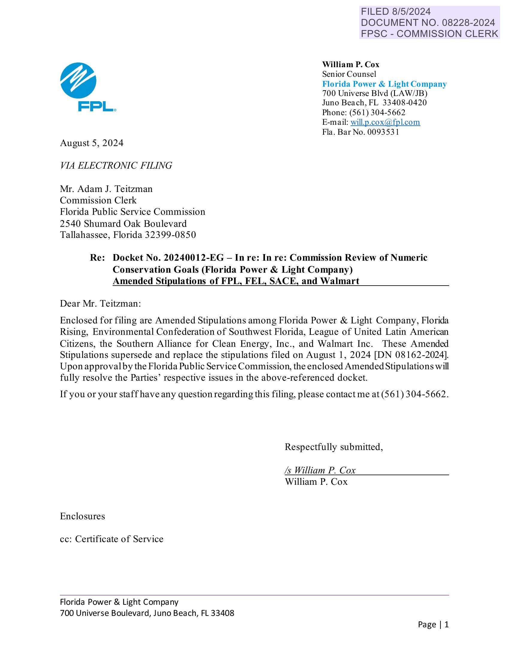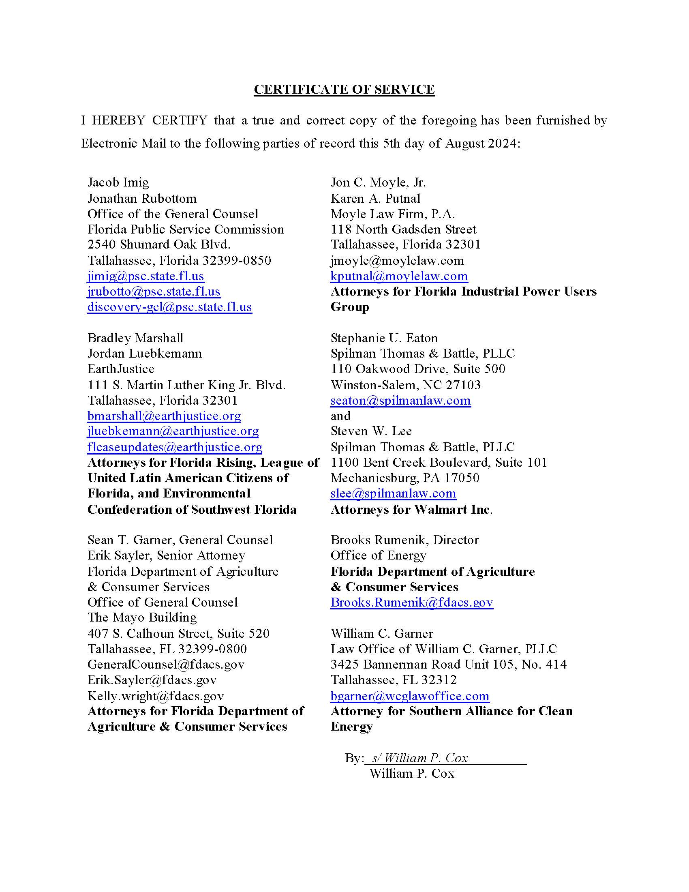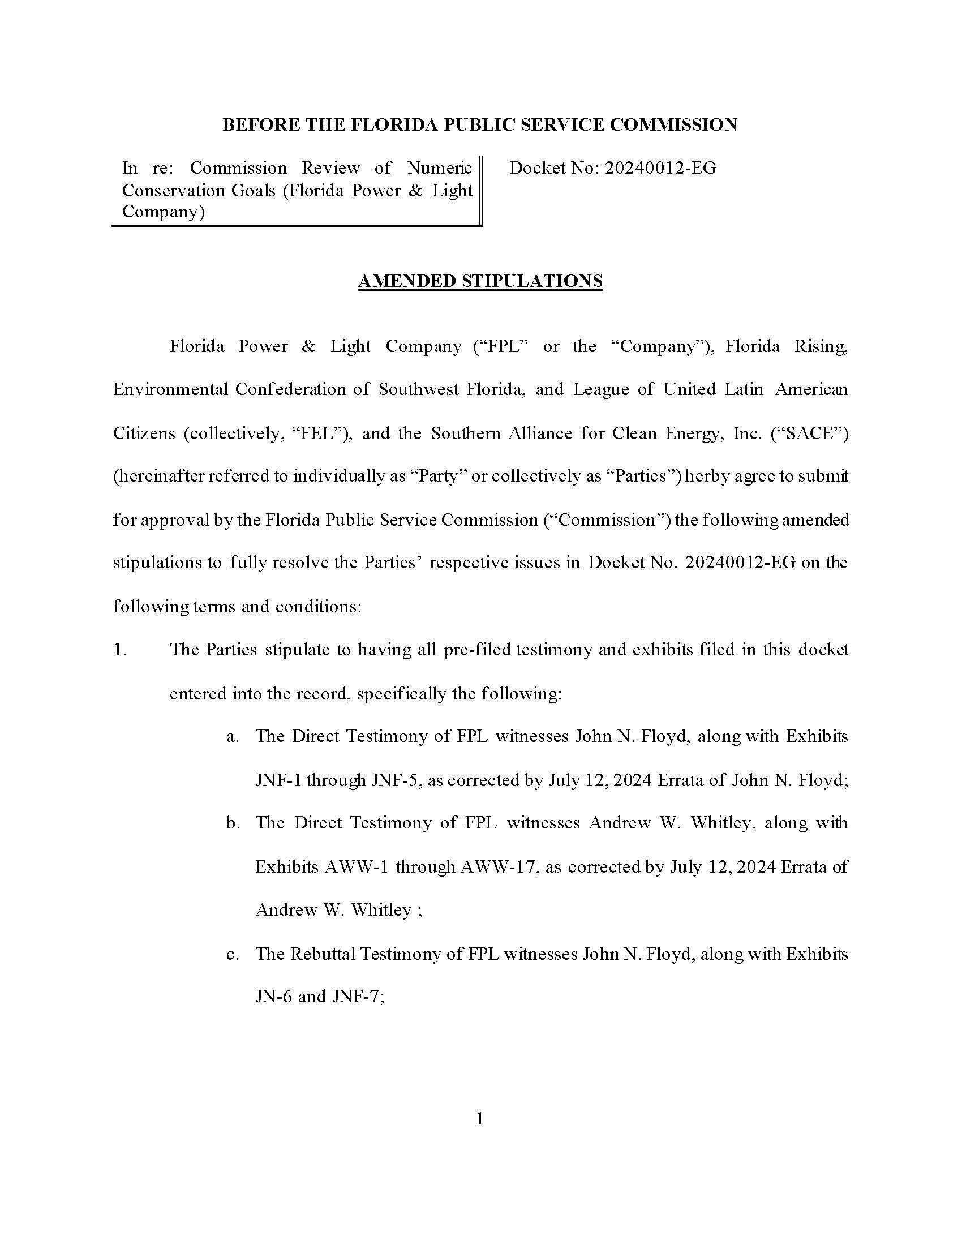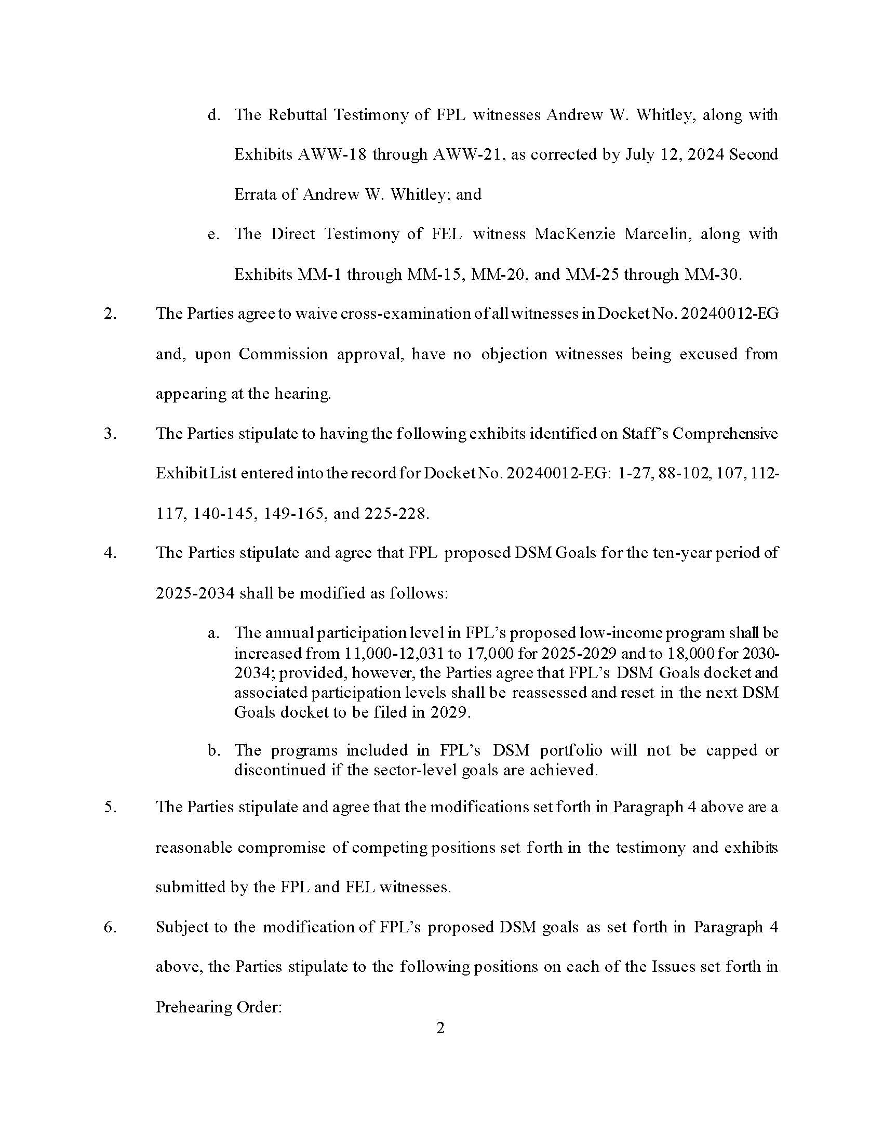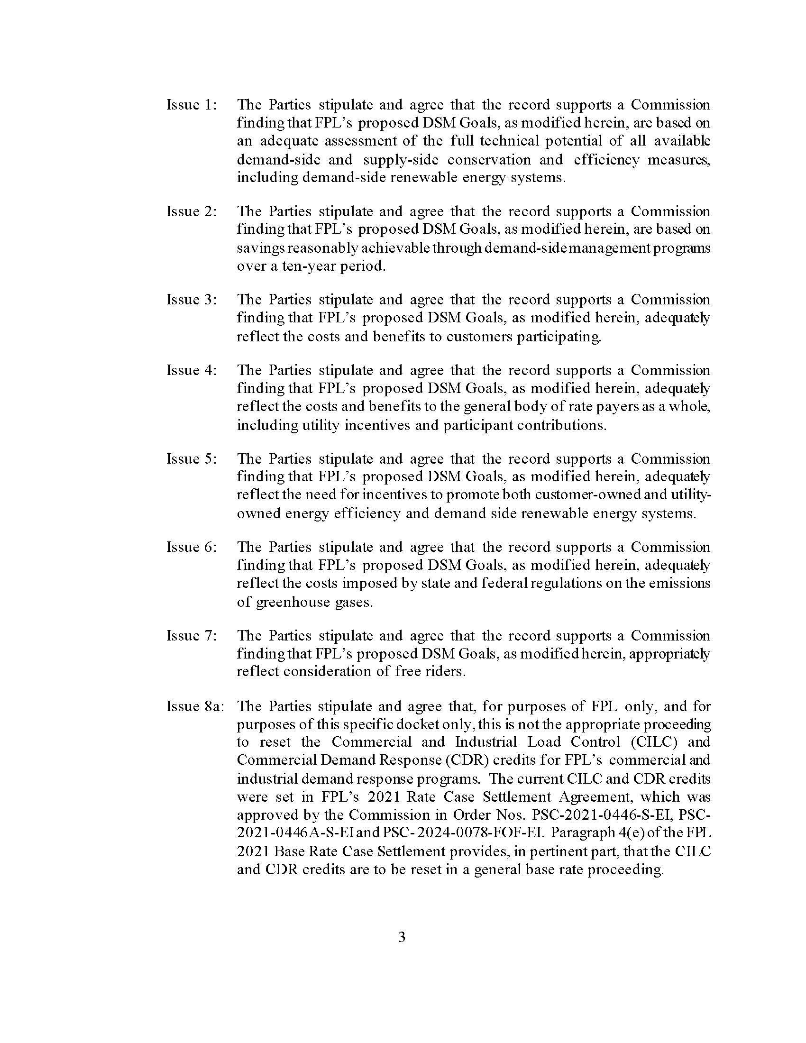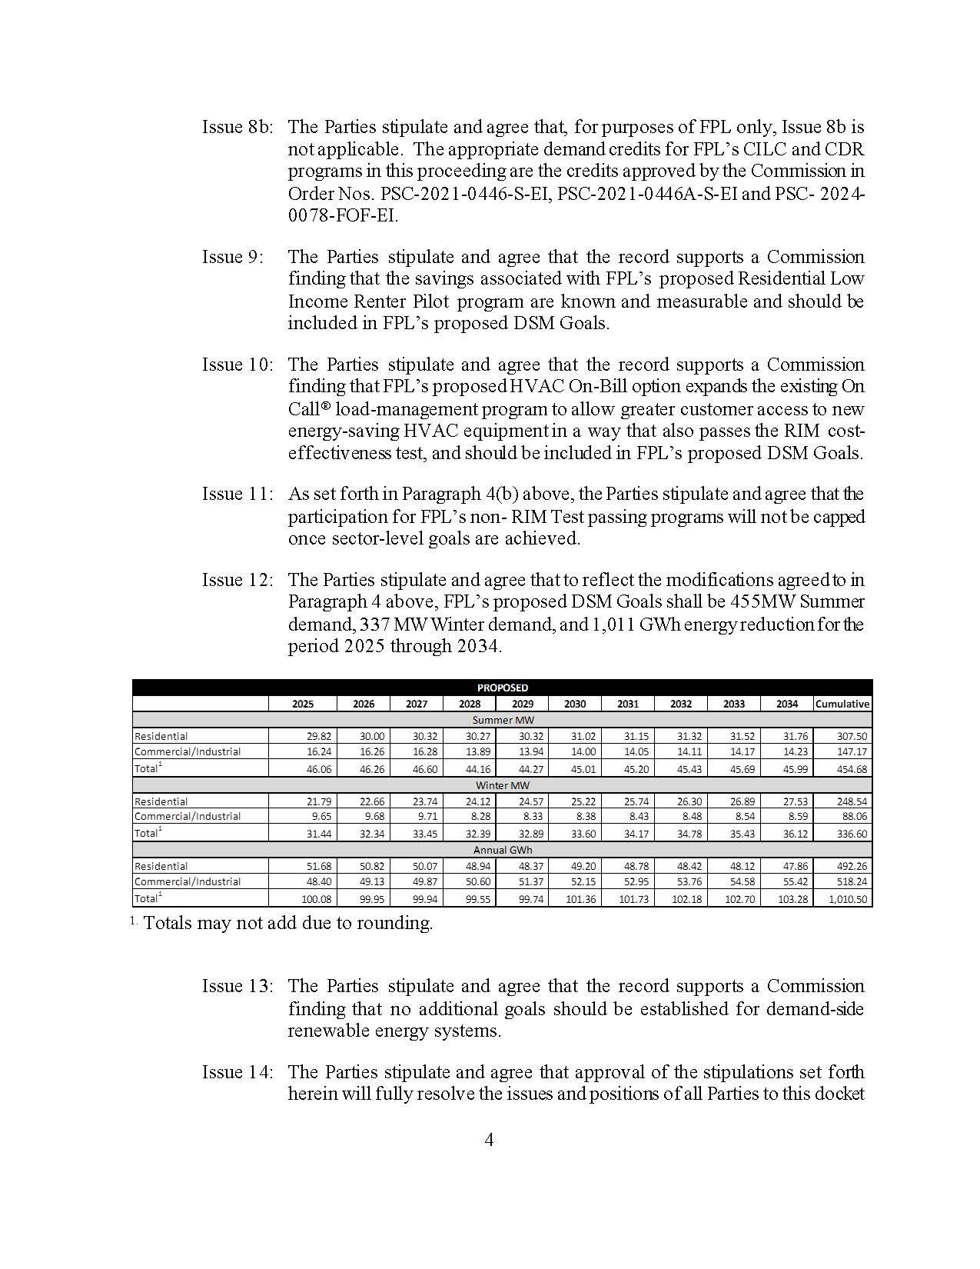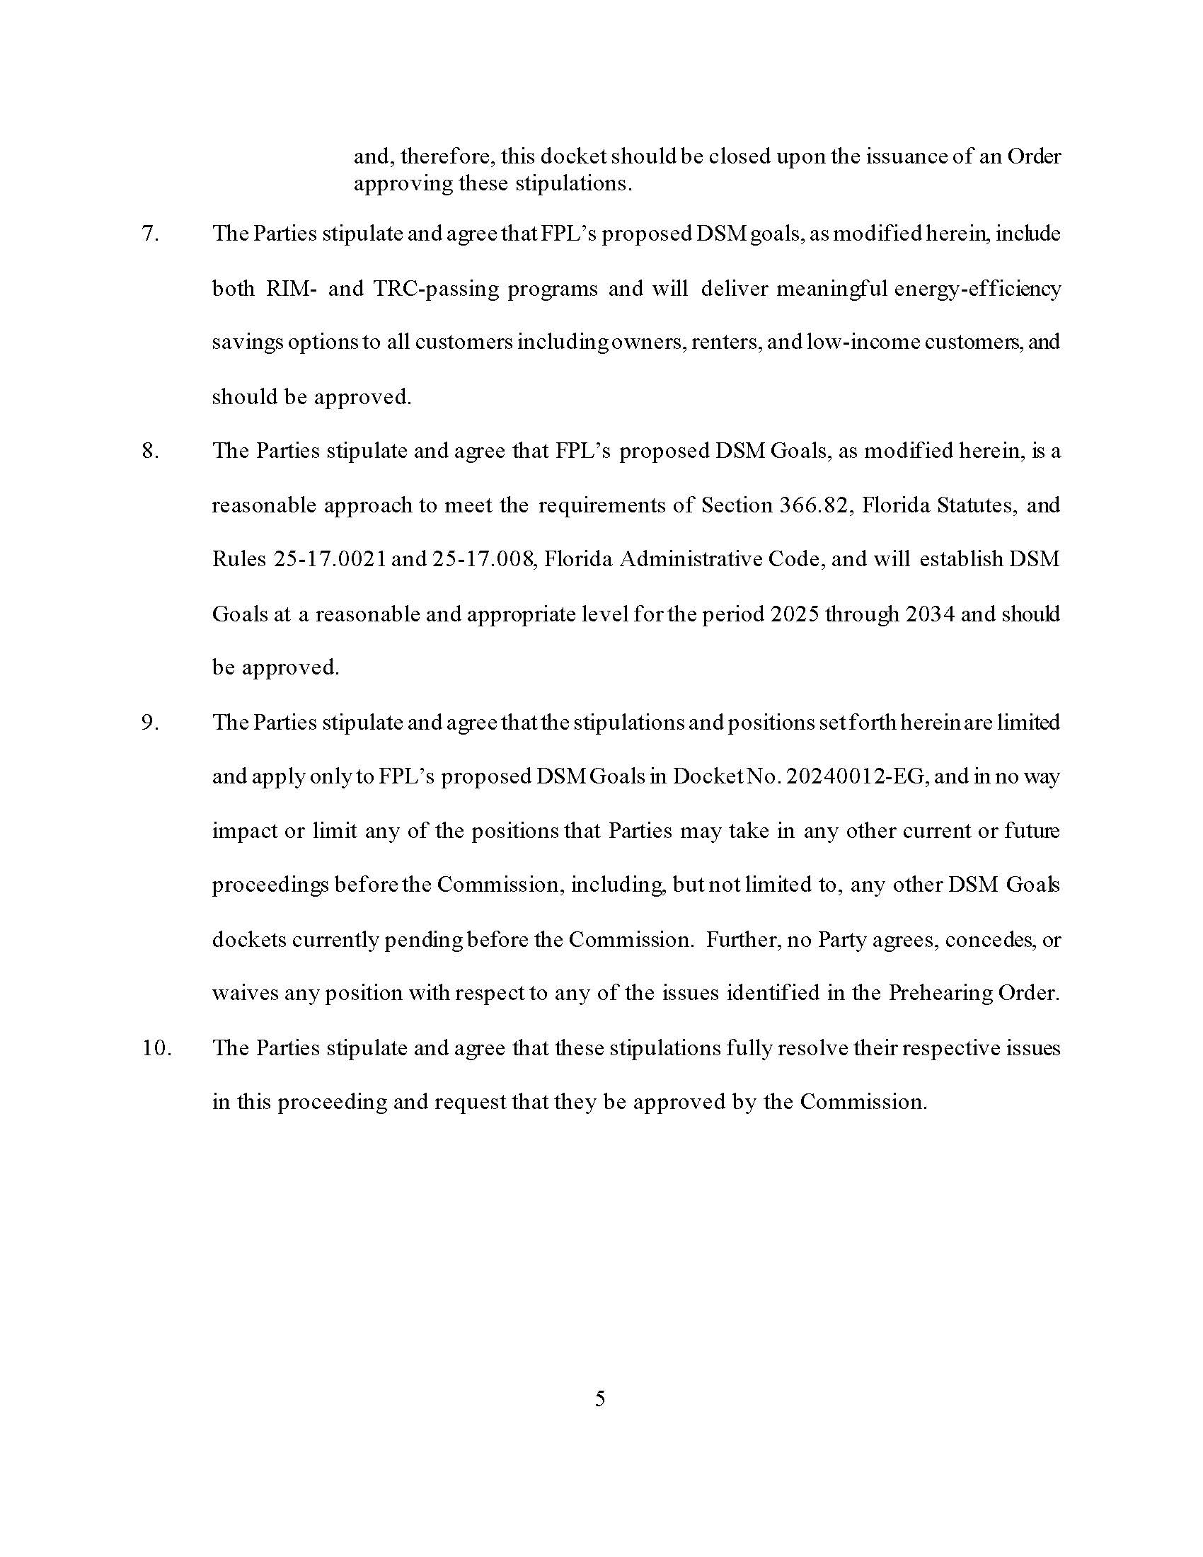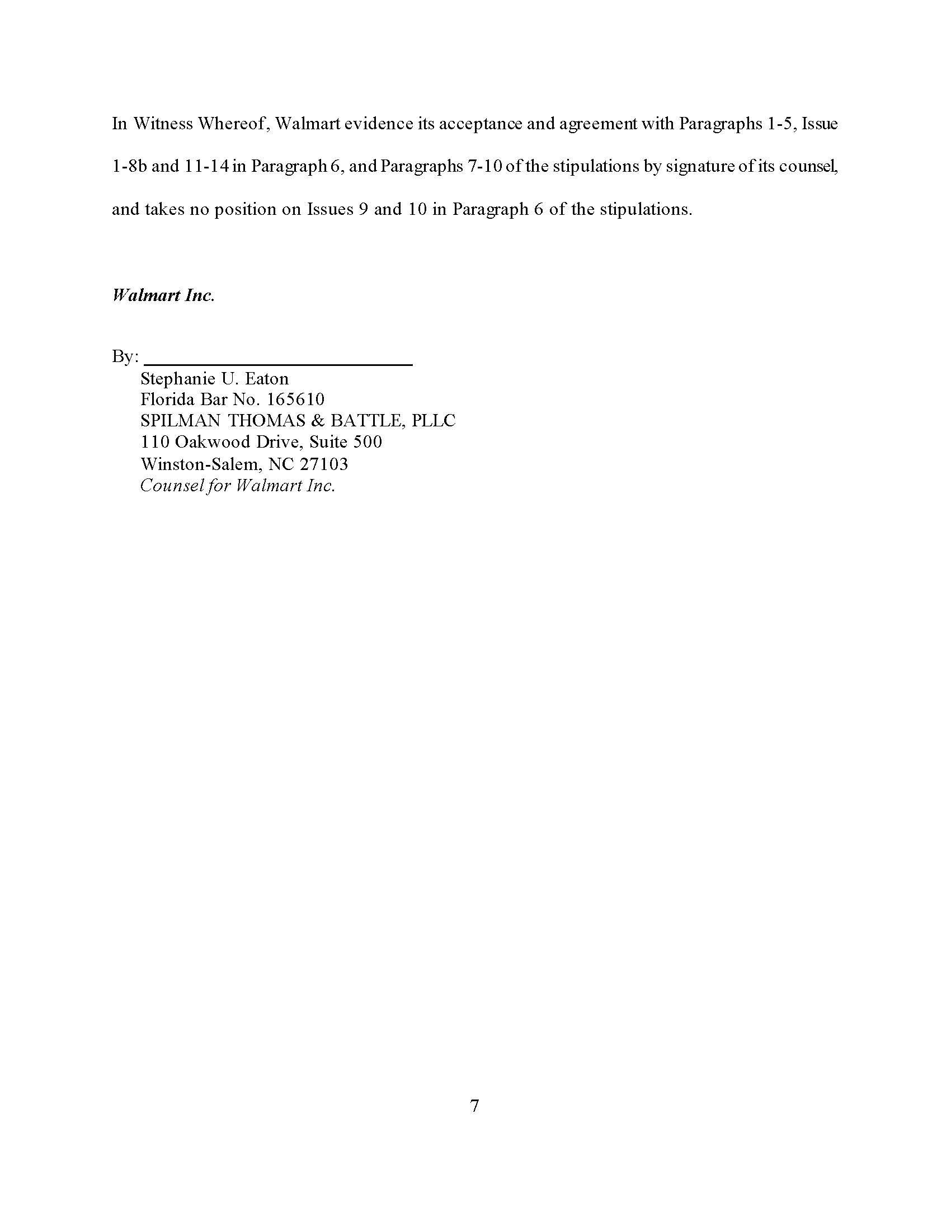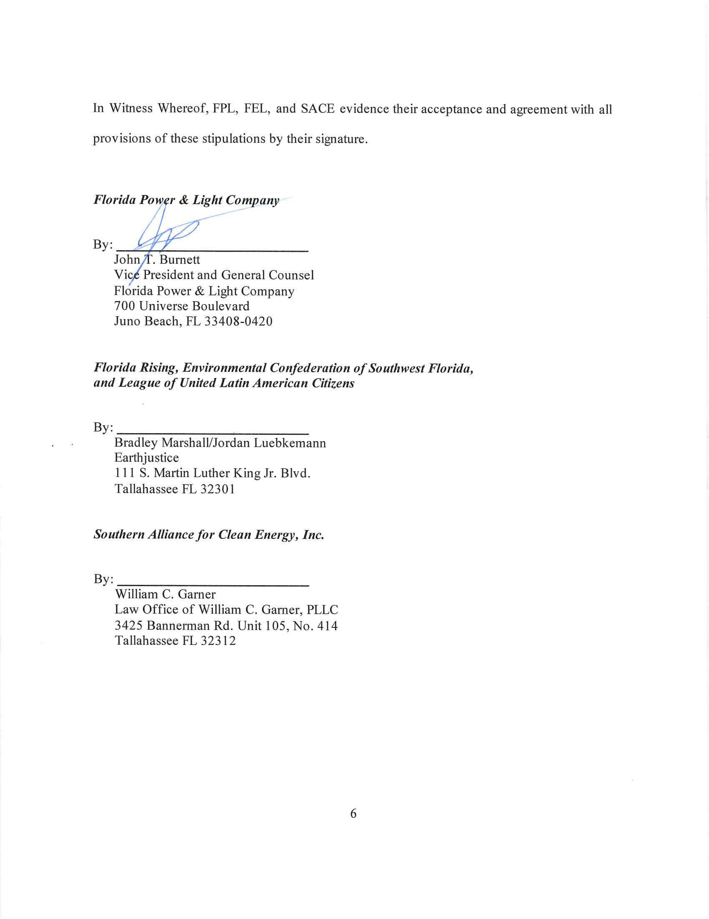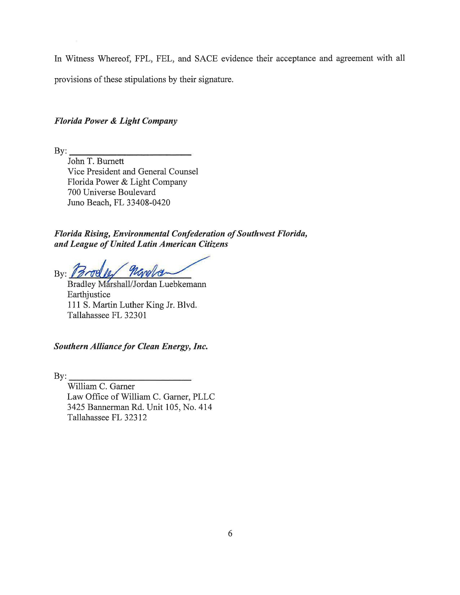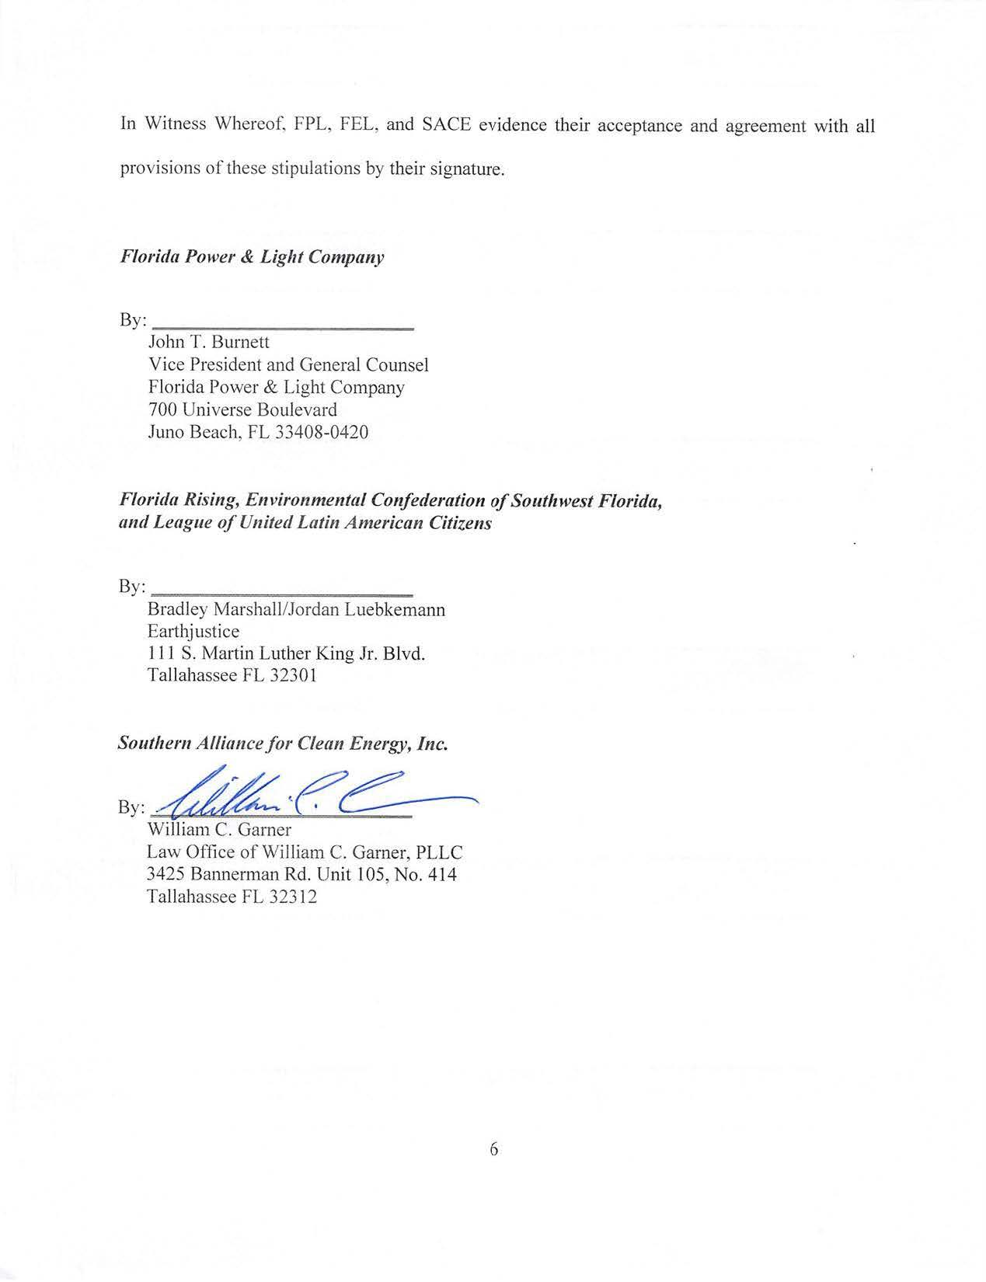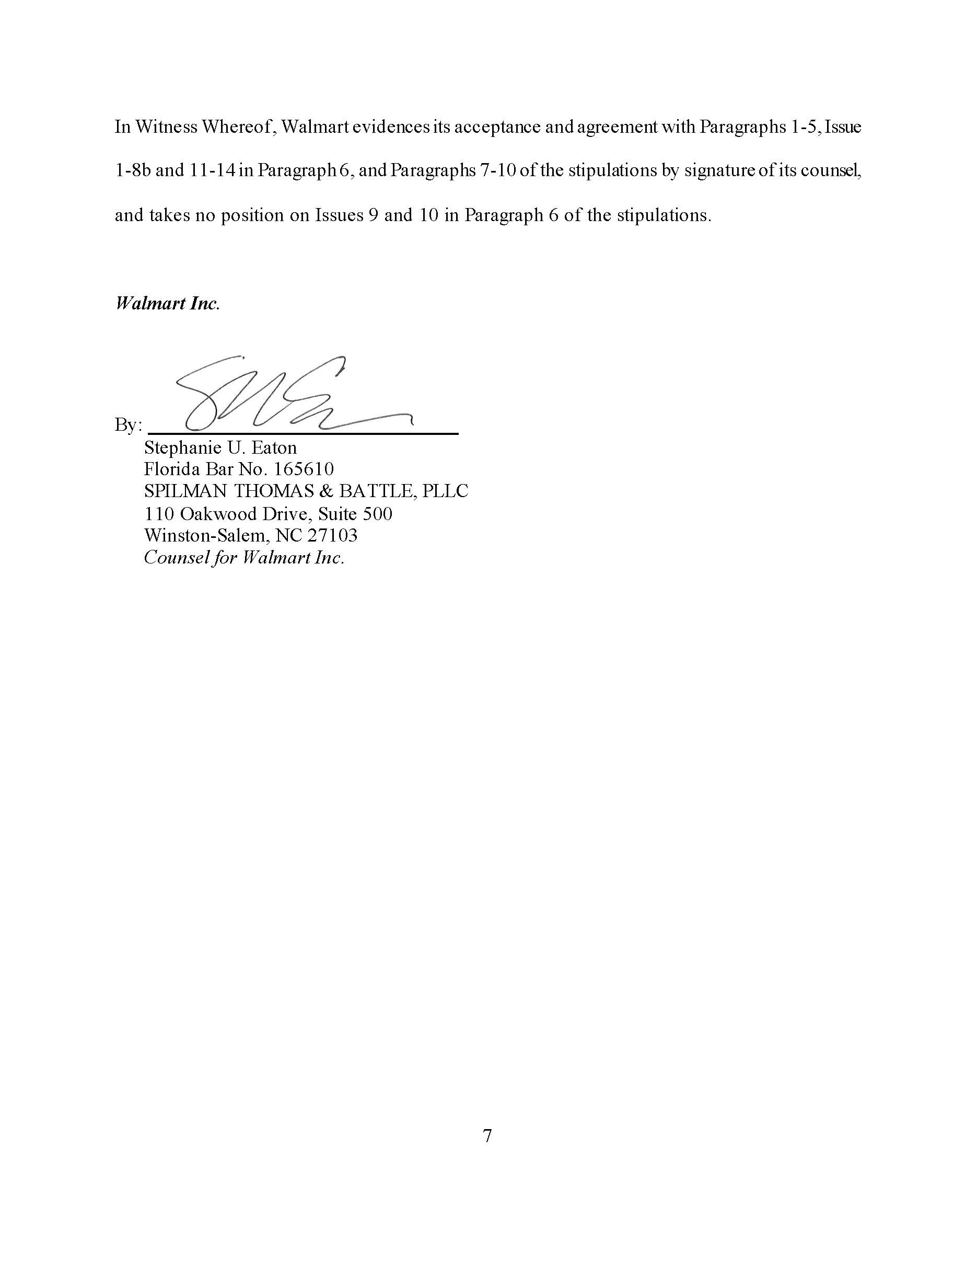

1. Sections 366.80 through 366.85, and 403.519, Florida Statutes (F.S.), are known collectively as the Florida Energy Efficiency and Conservation Act (FEECA).
2. Rule 25-17.0021(1), F.A.C.
3. *Id.* The Commission amended Rule 25-17.0021, F.A.C., after the 2019 goalsetting proceeding to streamline its FEECA process by requiring utilities to file goals based upon potential conservation programs. This allows the Commission to analyze the utilities’ proposed energy (KWh) and demand (KW) savings alongside the potential programs they plan to implement, giving the Commission better information as to the appropriateness of the goals. Thus, although a utility’s conservation plans and the underlying programs and measures to implement those plans are not approved at the same time as its goals, each utility must include in its filing sufficient information to support the appropriateness of its proposed goals.
4. Order No. PSC-2019-0509-FOF-EG, issued November 26, 2019, in Docket No. 20190015-EG, *In re: Commission review of numeric conservation goals* (Florida Power & Light Company); Docket No. 20190016-EG, *In re: Commission review of numeric conservation goals* (Gulf Power Company); Docket No. 20190017-EG, *In re: Commission review of numeric conservation goals* (Florida Public Utilities Company); Docket No. 20190018-EG, *In re: Commission review of numeric conservation goals* (Duke Energy Florida, LLC); Docket No. 20190019-EG, *In re: Commission review of numeric conservation goals* (Orlando Utilities Commission); Docket No. 20190029-EG, *In re: Commission review of numeric conservation goals* (JEA); and Docket No. 20190021-EG, *In re: Commission review of numeric conservation goals* (Tampa Electric Company).
5. Document No. 01562-2024, filed April 2,
6. Document No. 08228-2024, filed August 5, 2024, in Docket No. 20240012-EG, *In re: Commission review of numeric conservation goals (Florida Power & Light Company)*, Amended Stipulations of FPL, FEL, SACE, and Walmart*.*
7. FPL’s Response to Staff’s 4th Set of Interrogatories, No. 86, Attachment 1, p. 4.
8. FPL’s Response to Staff’s 4th Set of Interrogatories, No. 86, Attachment 1, p. 10.
9. Residential HVAC On-Bill participants would be subject to three distinct tariffs: the Residential On Call® tariff associated with the On Call® program (8.217-8.218), the Optional HVAC Services Agreement (9.858-9.866), and the Optional HVAC Services Rider (8.220-8.221). *See* (EXH 156, FPL’s Response to Staff’s 1st Request for Production of Documents, No. 1)
10. HVAC Services Agreement, para. 9.
11. FPL’s Response to Staff’s 6th Set of Interrogatories, No. 95d. (“Customers are required to install a unit that *meets, at a minimum, current federal efficiency standards*…”) (emphasis added).
12. HVAC Services Agreement, para. 13(a).
13. HVAC Services Agreement, para. 13(d).
14. HVAC Services Agreement, para. 13(e).
15. Although FPL states that “the nature of the stipulations reflecting a ‘settlement’ on all issues . . . was confirmed by FEL’s counsel at the hearing,” (FPL BR 4), FEL’s counsel did not use the term “settlement.” *See* (TR 24)
16. FPL’s representative stated “We would appreciate the opportunity to file a legal brief on (Issue 10) and give that to [the Commission] to consider.” (TR 18)
17. *See* Section 366.82(7), F.S. (providing that DSM measures included in a utility’s FEECA plan must be both “*within the jurisdiction of the [C]ommission*” and“*likely to be effective*”) (emphasis added).
18. The HVAC transaction between FPL and participating customers would be governed by the Optional HVAC Services Agreement (9.858-9.866), and the load management service involved in the HVAC On-Bill option would be governed by the Residential On Call® tariff, (8.217-8.218), associated with the existing On Call® program and by the Optional HVAC Services Rider (8.220-8.221). *See* (EXH 156, FPL’s Response to Staff’s 1st Request for Production of Documents, No. 1).
19. Transcript – Deposition of John Floyd, July 12, 2024, at p. 8 (stating that the provision of a new HVAC unit and maintenance services is “new” and is “not something that FPL has done before as a DSM program”).
20. Chapters 670-680, F.S., codify Florida’s version of the Uniform Commercial Code (“UCC”). Although FPL argues that the UCC does not apply to activities regulated by the Commission, (FPL BR 18), Chapter 672, F.S., expressly provides that it applies to “transactions in goods,” irrespective of what agency or governmental body might have power to regulate the transaction or the parties involved. Section 672.102, F.S.
21. HVAC Services Agreement, paras. 2.-6.
22. HVAC Services Agreement, para. 13.
23. FPL’s Response to Staff’s 6th Set of Interrogatories, No. 105. Staff’s interrogatory asked: “If a participant exercises the “Customer Purchase Option” under section 13(e) of the service agreement, is the effect that title to the HVAC passes from FPL to the participant in exchange for the ‘purchase option price?’ Why, or why not?” FPL’s response stated: “Yes, if the participant exercised section 13(e) of the service agreement, the effect is that title to the HVAC unit passes from FPL to the participant in exchange for what is defined as the ‘purchase option price’.”
24. HVAC Services Agreement. Additionally, FPL witness Floyd indicated that the control over the HVAC unit was a function of the load control aspect of the HVAC On-Bill option rather than the HVAC transaction, stating that FPL’s unregulated affiliate, FPLES, has a financing arrangement structured similarly to the Optional HVAC Services Agreement in that it involves utility ownership of the HVAC unit during the term, but the FPLES program is “characterized as a lease [rather than a service contract] because FPL does not have the load management control capabilities.” (EXH 228, MPN E4149-51)
25. Order No. 24570-EI, issued May 22, 1991, in Docket No. 900314-EI, *In re: Investigation of the Appropriateness of Appliance Sales by Investor-Owned Utilities.*
26. Stating that the revenue requirement will include a “return on the unrecovered investment using the [Commission]-approved weighted average cost of capital (WACC)”).
27. Stating that the revenue requirement for the HVAC units will include a “rate of return on the recovery of the capital cost [that] will be set at FPL’s Commission-approved midpoint return on equity for the ECCR clause.”
28. Transcript – Deposition of John Floyd, July 12, 2024, at pp. 37, 61.
29. Florida City Gas (“FCG”) offers an “equipment financing” tariff for gas conversion, compression, or renewable natural gas equipment to be owned by the customer with the costs, including overall cost of capital, being recovered in customer’s monthly rates; FCG also offers a “Renewable Natural Gas Services” tariff that provides various equipment to biogas-producing customers “for the purpose of conditioning and upgrading [the customer’s] biogas to Renewable Natural Gas (“RNG”) such that the RNG can be utilized onsite by [the customer] and/or to be delivered into [FCG’s] distribution system.” *See* Florida City Gas, FPSC Natural Gas Tariff, Vol. 11, Tariff Sheet Nos., 26, 74.1-74.3, available at https://www.floridacitygas.com/wp-content/uploads/FCG%20Master%20Copy%202024%20-%20v03122024.pdf. FPL’s existing Optional Supplemental Power Services (“OSPS”) tariff offering allows “residential customers [to] have the option of receiving an FPL-owned backup generator in exchange for making monthly payments designed to fully recover the costs incurred.” (FPL BR 22); *see also* Order No. PSC-2019-0220-TRF-EI, issued June 3, 2019, in Docket No. 20190034-EI, *In re: Petition for approval of optional supplemental power services pilot program and rider, by Florida Power & Light Company.*
30. *See, e.g.*, Antonin Scalia & Bryan A. Garner, *Reading Law: The Interpretation of Legal Texts* 252 (2012).
31. Order No. PSC-99-1047-PAA-EI, issued May 24, 1999, in Docket Nos. 990250-EI and 990244-EI, *In re: Gulf Power Company*. (removing from equity “non-utility investment consist[ing] primarily of receivables arising from the sale of appliances to customers”).
32. Order No. 5688, issued April 2, 1973, in Docket No. 72344-GU, *In Re: Petition of South Florida Natural Gas Company for Authority to Increase Its Rates and Charges.* (finding the sale of appliances to be “non-jurisdictional to this Commission, and, therefore, the expenses connected therewith should be allocated to non-utility”).
33. Order No. 23573, issued Oct. 3, 1990, in Docket No. 891345-EI, *In re: Petition of Gulf Power Company for an increase in its rates and charges.* (stating that “we [the Commission] believe all non-utility investment should be removed directly from equity when reconciling the capital structure to rate base unless the utility can show, through competent evidence, that to do otherwise would result in a more equitable determination of the cost of capital for regulatory purposes”).
34. “The [C]ommission shall also expressly consider the conservation measures taken by or reasonably available to the applicant or its members which might *mitigate the need* for the proposed plant and other matters within its jurisdiction which it deems relevant.” Section 403.519(3), F.S. (emphasis added).
35. Document No. 08228-2024, filed August 5, 2024, in Docket No. 20240012-EG, *In re: Commission review of numeric conservation goals (Florida Power & Light Company)*, Amended Stipulations of FPL, FEL, SACE, and Walmart, p. 4*.*